1. Agenda:
   1. Store a Message ID in DB Table.
2. 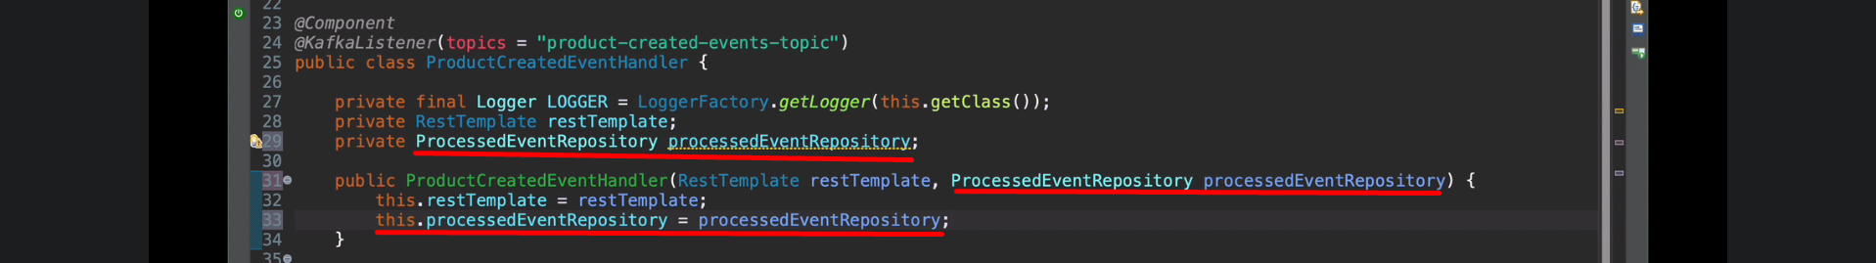
3. 